3D printing of teaching aids for school

Elementary school
Náměstí Republiky 902/9, Znojmo 66902
Contents:
Introduction 4
Annotation 4
Objectives 4
Organization 4
Methodological procedures 5
Cubic decimeter 5
Desired characteristics 5
Method 5
Photo: 8
ARDA teaching prisms 10
Method 10
Photo: 10
Magnetic letters 11
Desired characteristics 11
Method 12
Photo: 13
Cubes with letters 15
Desired characteristics 16
Method 16
Photo: 19
Fractions 20
Method: 20
Photo: 22
3D maps 23
Desired characteristics 24
Method 24
Other possibilities of use 32
Photo: 32
Commemorative tags for first graders 35
Desired characteristics 35
Method 35
Photo: 37
Conclusion 38

Introduction

Annotation
The essence of the project is the creation of student competencies to work in a 3D graphic environment and the creation of a methodology for teaching 3D modelling. 2D graphics programs are already being taught in elementary school, but the 3D environment places much higher demands on the student's imagination and orientation when working with adequate software. The project has the ambition to gradually introduce students to the principles of working with programs for 3D modelling, with a subsequent link to the teaching of a specific program that is suitable for students in sixth through ninth grade of elementary school. The output of the lesson will be the teamwork of a group of pupils to design and create a set of school supplies for a specific subject and grade. The leader of the student project will determine the task, the students together will design the basic attributes of the tools. After approval by the leader of the student project, the students will work on specific models within the whole group. The project manager continuously checks the progress of the work. The entire group also participates in the inspection of the progress of work, together they consult new proposals and resolve deficiencies. Students print the final modelled tools on a 3D printer as a complete set for the given subject.
The project is planned to be sustainable. Depending on the nature of the overall output, it is planned either to work with a new group of pupils in the 8th year of elementary school, or to introduce 3D modelling into the teaching of computer science.

Objectives
- Introducing students to the principles of 3D modelling and 3D printing technologies
- Creation of methodology (worksheets) for 3D modelling
- Pupils' practical skills in 3D modelling - creation of teaching aids
- Use of acquired skills in the educational process
- Development of student creativity
- Development of group teamwork

Organization
The project was implemented in the form of a voluntary group for pupils of the eighth and ninth grades. Due to the nature and organization of the teaching, it was absolutely necessary to create two groups. The ring took place every 2 hours once every 14 days. Due to the onset of measures related to the covid19 disease, a significant majority of meetings took place so-called "online", which actually made the entire project concept more difficult.

Methodological procedures

All models were created by the students in the Tinkercad program. The program is intuitive, easy to understand and ideal for children. Here, the teacher has an overview of the children's projects in progress, can check them, guide them correctly and help them. The program runs in an online environment and is completely free. These benefits have proven to be essential and invaluable in the age of online learning.
We used the PrusaSlicer program for slicing. Given the use of the Prusa MK3S printer, the reason is logical.
Individual aids are not meant as precise manufacturing procedures. The purpose is to inspire others and show what tools can be created with the help of 3D modelling and 3D printing and to draw attention to possible errors and difficulties that may occur during the creation. This attitude gives room for ideas and improvements.

Cubic decimeter

This teaching aid can be used in physics and mathematics. In schools, you can see an older wooden design in a tin box. The students tried to create a 3D model of this tool with the subsequent possibility of their own production in any colour and in any number of pieces.

Desired characteristics

- the first layer will contain 9 pieces of two-colored blocks 10 x 1 x 1 cm
- one block of the first layer will measure 9 x 1 x 1 cm
- the first layer is completed by a cube of size 1 x 1 x 1 cm
- the next 4 layers will be in the form of 10 x 10 x 1 cm plates in two different colours
- the rest will be completed by a plate measuring 10 x 10 x 5 cm
- 1 x 1 x 1 cm cubes will be shown on the boards in the form of notches
- The pupils agreed that the aid would be printed in a combination of white and blue.

Method
When creating the aid, it is necessary to draw students' attention to an important circumstance. Individual blocks and tiles are placed together and there is always a gap between them. If we made it using exact dimensions, the dimensions would not fit during folding and the entire set would not have the same dimensions. It is necessary to discuss this with the pupils in advance, they will eventually realise it themselves. It is therefore always necessary to reduce the dimensions of each model by 0.2 mm for the contact surfaces.
Considering the above, a 1 x 1 x 1 cm cube has real dimensions of 0.98 x 0.98 x 0.98 cm.
As a solution to the two-colored blocks, the students chose a central prism model, onto which printed individual blocks with a hole in the middle are strung. The assembly is completed on both sides by solid cubes, which are placed on the central prism and glued with an instant glue. This solution turned out to be excellent. The blocks are precise, and the time-consuming two-colour printing is eliminated. We just remind you that you have to reduce all contact surfaces by 0.2 mm, which also applies to the height of the blocks.
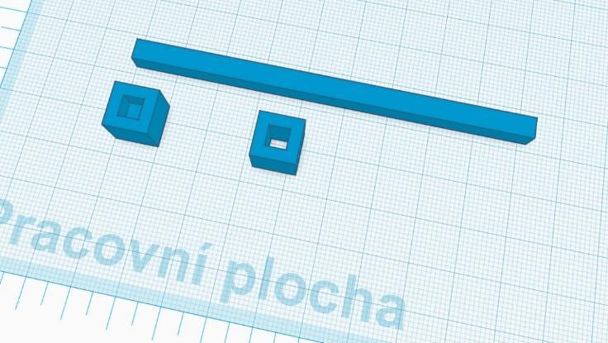
Solution of the block 10 x 1 x 1 cm. A block of 9 x 1 x 1 cm is solved in a similar way.
Pupils intuitively solve the design of 10 x 10 x 1 cm and 10 x 10 x 5 cm plate models by creating one large cube with the subsequent creation of notches. This procedure is possible, but it is very time-consuming and inefficient. Here is a suitable space for the input of the teacher who will teach the pupils to duplicate objects. The duplication feature is absolutely essential in Tinkercad and here is the perfect opportunity to teach it to children. It is a very simple duplication and children can easily understand it.
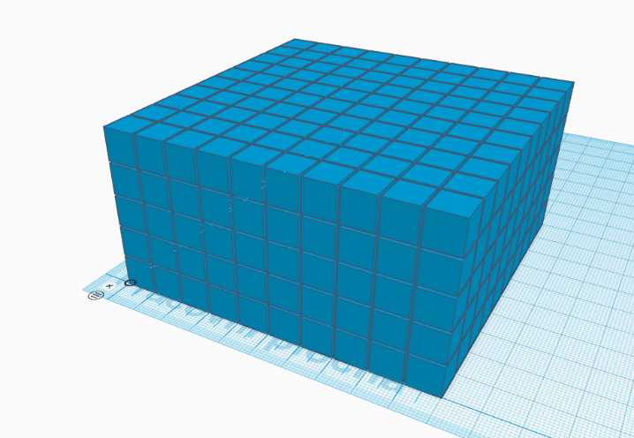
The last step is the production of the packaging in which the plates, sticks and dice are stored. We increased the internal dimensions by 1 mm so that the individual components can be easily placed in it. External dimensions do not matter. The outer part can of course be made with inscriptions, logos etc.
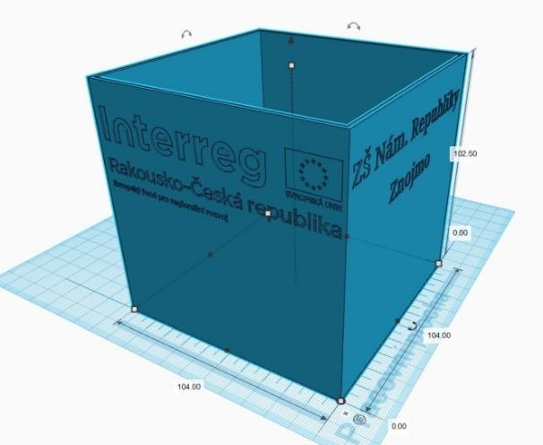

Photo:
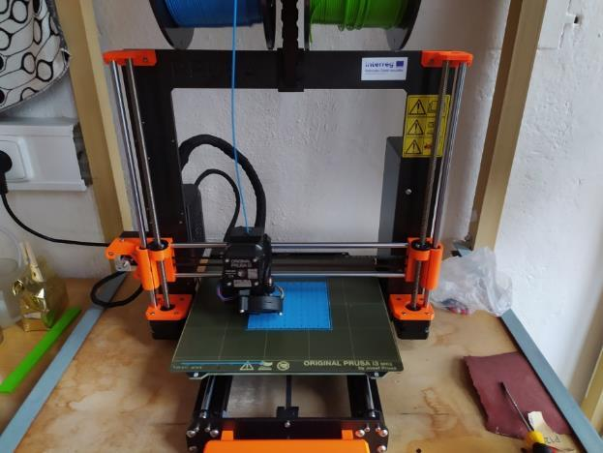
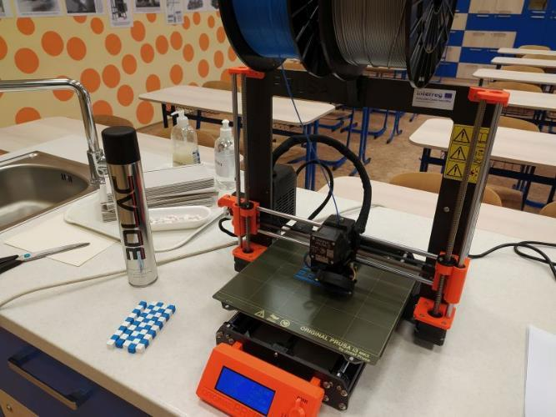

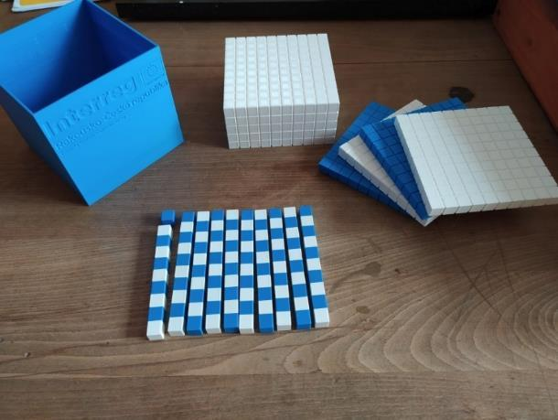
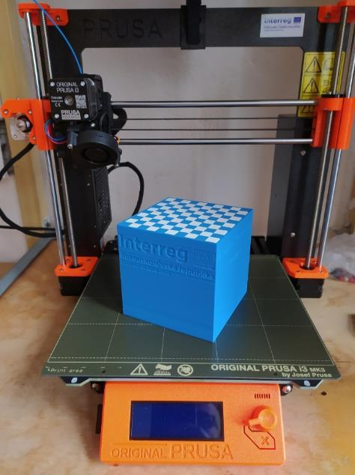

Two student groups, a total of 8 pupils, worked on the project models as a team. Some tried their own different procedures, but they turned out to be unnecessarily lengthy and ineffective. The teachers' intention was not to interfere with their procedures and to let the students find out which of the procedures is more appropriate. Of course, the teacher's intervention is necessary in the form of an explanation of the principle of duplicating work.
With correct understanding, students will usually find a more advantageous solution on their own.
Of all the solutions, the above-mentioned solution proved to be clearly the best, which is why it was implemented. Unfortunately, school had to close due to the pandemic of Covid19, so most of the work took place online, and the actual printing took place without the participation of the pupils.
Special preparation from the teacher is not necessary provided he knows the Tinkercad program, slicing and 3D printing.
The price of the model depends on the filament used, its consumption is approximately 550 grams (depending on slicing). At a filament price of CZK 650/kg, the final price of the model is around CZK 350.

ARDA teaching prisms
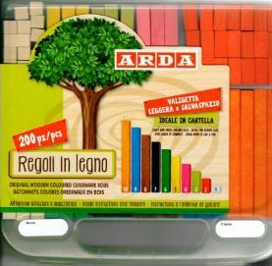
A special needs teacher noticed the possibilities of 3D modelling and 3D printing and asked our group if it would be possible to make blocks for teaching addition and subtraction to children with learning disabilities. She showed us a wooden tool called ARDA as an example, but it lacked the length of the stick.
After the experience of making the previous model, the children already knew how to duplicate, so they could apply their new skill here. The production of educational prisms is very simple, the design of the box in which the individual blocks would be stored turned out to be the more complex. Since it was solved in the form of two floors, the teacher eventually took on this task.

Method
In the end, one student took on the task and created sticks measuring 1 x 1 cm and ranging from 1 to 10 cm in length. There are lines on the sticks, which can be used to calculate their length.
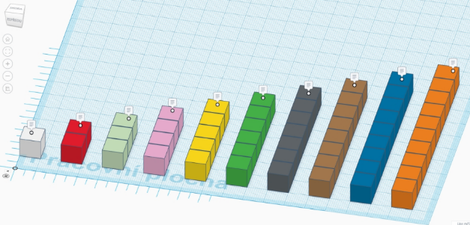
The box for sticks is two-tiered with a lid. Each box section is numbered. The number indicates the length of the blocks that are placed in the section.

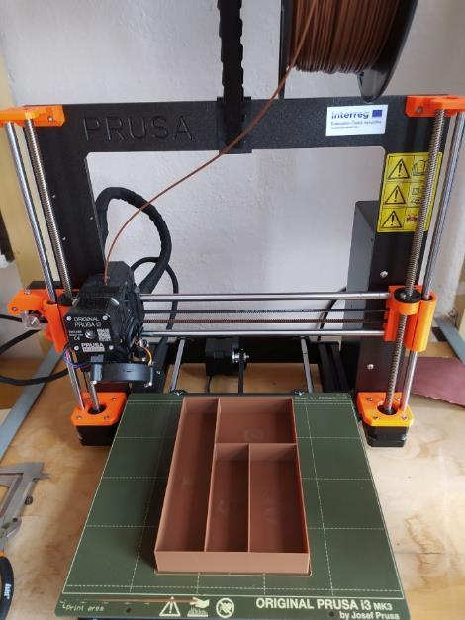
Photo:
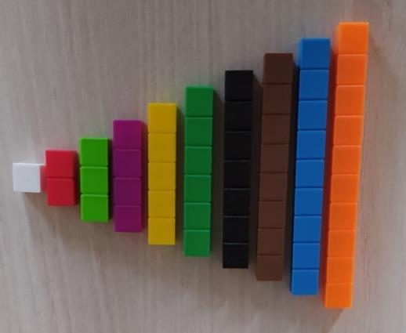

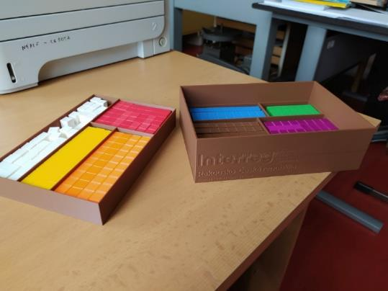

One pupil worked on the model during online teaching in cooperation with the teacher. He provided him with the necessary information about the dimensions and requirements from the special education teacher. All consultations took place online within the class. Due to its complexity, the work on the box was very difficult to solve in the online environment, so the teacher created the box. However, we assume that if the classes were to take place directly, the student would be able to create the box himself with the help of the teacher.
Working on the aid is trivial for an experienced teacher, without the need for special preparation.
Filament consumption per cube is 35 grams, per box 265 grams. So a total of 300 grams. At a filament price of CZK 650/kg, the final price of the model is around CZK 200.

Magnetic letters
The idea to create magnetic letters as aids for teaching reading and writing came from pedagogues from the 1st to 5th grade of elementary school. During the online meeting, the students clarified among themselves the meaning of the tool and the requirements for the modelling.

Desired characteristics
- the size of capital letters should be approximately 10 cm it is important to ensure that all letters and characters have the same proportion
- create commas and wedges separately, letters (e.g. Á, á, Č, č and similar) will be added (A + comma, C + wedge and so on)
- the letters CH and Ch are formed from individual letters C, c, h
- the position of the magnet in the letter is not essential. It is not necessary to put it exactly in the middle of the letter, the magnet is in the letter only to hold the letter on the board.
- the size of the magnet is 10 x 5 mm
- For each letter of the alphabet, we need a lowercase and an uppercase letter - we will use one Tinkercad workspace for both characters

Method
We will create the first letter "A" in Tinkercad. We will use the "Multilanguage" font, we don't need to set anything. Place the letter A in the workspace.
We turn on the ruler.
Now comes the important step, and that is enlarging the letter in all proportions (width, length, height). There is a procedure for this in Tinkercad. When enlarging the object in all proportions, we have to hold the "shift" key. This means... We move the mouse over the icon to change the size of the object (white square), hold down the shift key, press the left mouse button and enlarge the object.
Since the letters in the alphabet have different lengths and widths, the ideal dimension for enlarging all letters is their height. That means, we enlarge the letter until its height is 40 mm. It doesn't have to be exact, but ideally it should be between 39.5–40.5 mm.
Now we will create a hole for the magnet. We will create it from a cylinder with a diameter of 10.4 mm and a height of 5.2 mm. The opening needs to be slightly larger than the magnet, 2 tenths of a millimetre should be ideal for later gluing. For the cylinder, don't forget to set the maximum number of walls (64) to make the hole smooth. Place the hole for the magnet appropriately in the letter.
Combine the objects and we have the letter A.
Now we could use the same procedure to create a lowercase letter a, but we can simplify it considerably. We copy the already finished character "A" and paste it next to it in a free place in the workspace. We will ungroup this object. We click on the object of the letter A, in the settings we overwrite it with a small a, we appropriately place the already finished hole for the magnet (we had it left after cancelling the grouping). Group these two objects again and we're done. On one Tinkercad desktop we have a capital A, a small a, both characters have a magnet hole.
We'll name our model "Aa" and switch to the Tinkercad menu.
Now we will want to make the letters B b. It is not necessary to do the whole model again. We take model A and duplicate it. We click on "options" (gear symbol) and "duplicate". A new Tinkercad workspace called "Copy of Aa" will open for us. We rename it to "Bb" and work similarly as before. This means we ungroup both the large A and the small a, rewrite the large A to a large B, the small a to a small b, position the magnet holes appropriately, put them together and return to Tinkercad's main menu. Using the same procedure, we will create other letters.
The last step is to glue the magnets into the holes using super glue.
Due to the large amount of printing and other circumstances, we do not have this utility completed.

Photo:
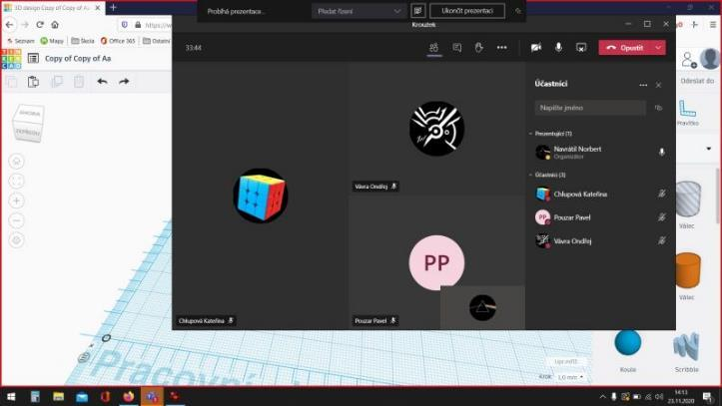
Online meeting – assignment and methodical help
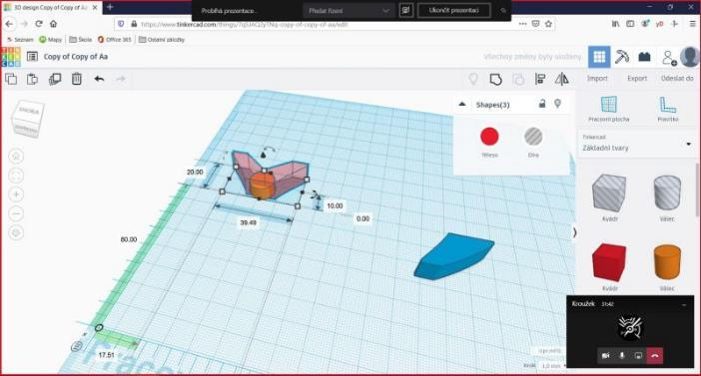
Creating a magnet pocket at the "wedge" sign
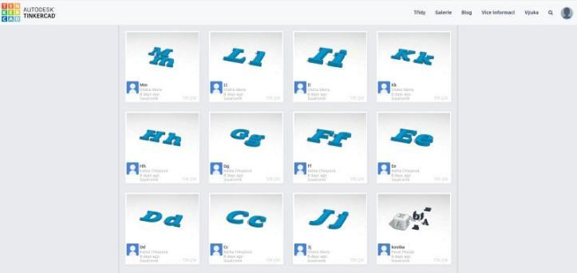
Already finished models of letters
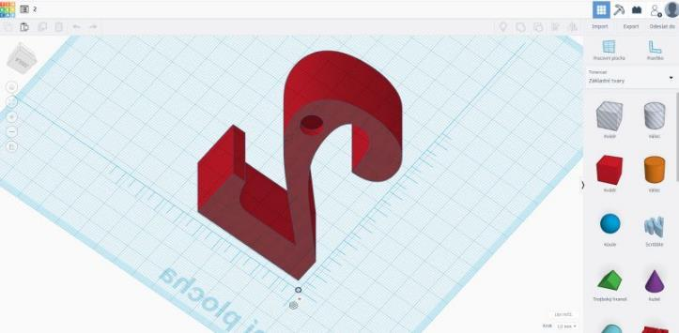
Work in progress model number 2

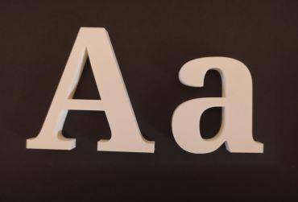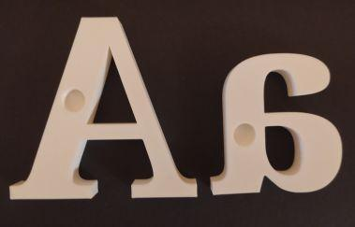
First test print of letters A, and – Prusa MK3S; white PLA filament Plasty Mladeč; print 0.2 mm
Both student groups, a total of 8 pupils, worked on the project models as a team. The letter models were divided between the two groups, and the students then divided the work among themselves. The models of the letters are ready, but we have not been clarified by our fellow teachers about the number and colour of the letters, so the final slicing and 3D printing have not yet taken place. However, we did a test print of the letter A. For this model, the filament consumption was 25 g, but different letters can be expected to have different consumption.

Cubes with letters
Cubes with letters are a traditional aid for teaching reading to children in the lower grades of elementary school. They are often made at home from paper or cardboard. After an agreement with the teachers, we created adequate models with the help of 3D printing.

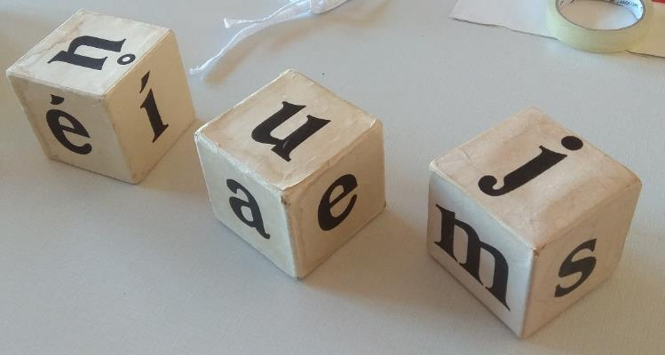

Desired characteristics
- three equally sized white cubes with black letters
- the size of the cube is 10 x 10 x 10 cm
- the letters on each die must be the same as on the template

Method
We let the students think and discuss possible solutions. Obviously, everyone will start with a cube object of specified dimensions, the discussion will be about how to create black letters on the cube from all sides. Two-color printing is out of the question here, so they will look for different solutions. We assumed three possible solutions and the students really came up with them.
Printing a white cube followed by pasting the printed black letters
Creating depressions in a white cube in the shape of letters and then coloring with black paint (alcohol marker, acrylic paints)
A combination of both, i.e. a depression in a white cube in the shape of letters followed by gluing printed black letters into the depressions.
These variants are then discussed by the teacher with the pupils, all pros and cons are considered. The following conclusions will emerge from the discussion:
The first variant is disadvantageous in that the sticking of the letters may not be exact and the cube is then not straight on the sides. It will handle badly and will not be pleasant in the hands of the teacher.
The second option brings the pitfalls of manual dyeing, i.e. laboriousness and very poor correction of any error. It can also be assumed that hand painting will not be accurate and aesthetic
The third variant eliminates the previous disadvantages, but it is necessary to correctly choose the size of the depression and to be able to create such a depression correctly. The students do not realise this yet.
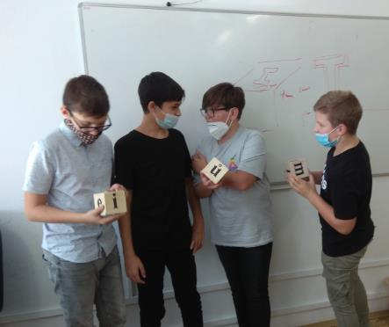
Creating a cube with the appropriate dimensions in Tinkercad is a trivial matter and even a complete novice can handle it.
We remind the students again about working with a ruler and in the orthographic view.
It is necessary to agree in advance with the students at what height (Z axis) the letters will be printed. It is completely counterproductive to omit this part, the students will choose their own height, the blocks will not be compatible, and we will get rid of the possibility to combine ready-made models from different students.
After agreement, the height of the letters in the Z axis was chosen to be 0.6 mm (3 layers of 3D printing), the recess in the cube must be a little bigger, our choice was 0.7 mm.
Another important thing that students may not realise is adjusting the letters to the correct size. They can realise that all letters should be approximately the same size, but they usually begin to adjust the size of the letters disproportionately. They will tend to align all letters to the same dimensions in all axes. They become aware of the problem with the letter I. Here the teacher's intervention is necessary to explain to the students that they cannot change the size of the letters in the X and Y axes independently of each other, but simultaneously, i.e. proportionally. We need to establish the same (or at least approximately the same) size of the letters in the Y-axis (provided that we have all the letters built in the correct axes). We then proportionally change the size of the individual letters to the specified size in the Y axis. We do not deal with the size in the X axis (width of the letter), we adjust the height in the Z axis to the specified size of 0.6 mm.
The formation of depressions is not as clear-cut as the students think. Here, the teacher must provide methodical help to the pupils. If they are just starting out with modelling, he will explain to them the advantage of the auxiliary work surface, where the need to shoot objects to the right angles is eliminated. When creating the depressions, we use ready-made letters, copy them, create an additional surface on the side of the cube where the letter will be placed and insert the object. Now it is necessary to create a depression from the letter, which must be about 1 mm larger on all sides than the pasted letter. All students (we dare to say without exception) make a proportional enlargement of the whole letter, which is a mistake and the letter could not be pasted into the depression. The teacher must explain this circumstance to the pupils, that by enlarging the entire letter, the entire shape will also shift and the depression created will not correspond to the letter. The letter must be enlarged all around, which is a similar effect to, for example, bold text in a text editor. The "bevel" function in the text object settings is used for this purpose. To create a depression, we set the value of the letter object to 0.3. We change the object to a "hole", set a 0.7 mm cutout to a cube and merge. This is how we create depressions on all sides of the cube according to the original model. We will use the same procedure to create two more cubes.
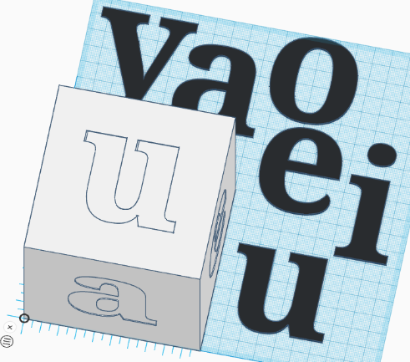
We print our own cube, print letters in a different filament colour and then stick them on the cube with instant glue. Caution is advised here. The chosen letter height of 0.6 mm is not ideal, because the second glue can seep through the letter and splatter your fingers, which will leave irreversible marks on the letter and the cube. For the next model, we are considering a letter height in the Z axis of 1 mm and a recess depth of 1.25 mm. Another problem occurred with the glue, which was opened a long time ago. Such glue left white spots on the black filament, which we had to redo with a black alcohol marker. Despite everything, the cube models with letters are successful and practically used in the teaching of the first grades.
The model does not require special preparation of the teacher, but it does require a correct explanation of the work in Tinkercad. 8 pupils from both groups worked on the models, we selected the most successful 3 pupils from all the models and combined their work. We did not inform the students about the authors of the used models and emphasised that it was their joint work.
450 grams of filament were used to print three cubes. The price of instant glue is negligible.

Photo:
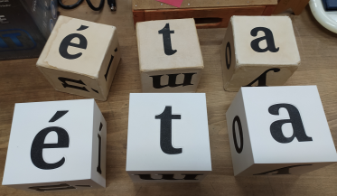
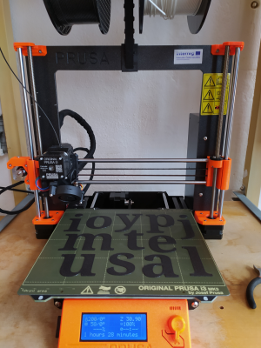

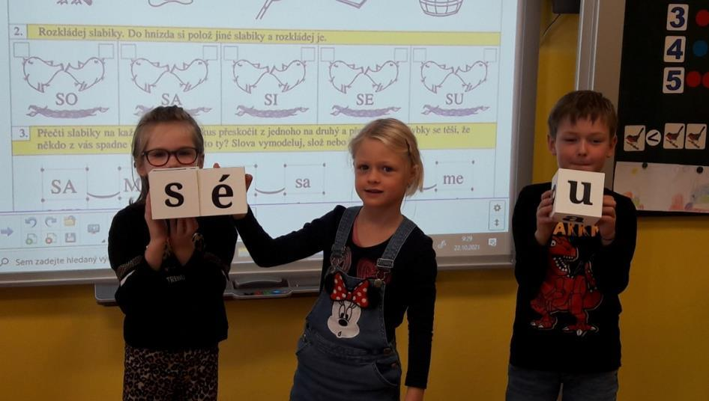

Fractions
The idea for a maths tool to teach counting with fractions was inspired by Prusa's website for schools, where a similar tool is available for download. However, our students wanted to go their own way, and even though the tool is very similar to the original one, it went through a separate design and solution. They differ primarily in size and number of parts.
The whole tool is designed in such a way that a flat disk is cut into parts that correspond to their fractional expression. For example, a disk divided into 4 parts means that each part of the disk represents a fraction of 14. The number of disks then corresponds to the number of different fractions. We created 7 discs in the group, i.e. fractions half, third, quarter, fifth, sixth, eighth and tenth.
Parts of the disk can then be put together and thus learn addition and subtraction of different fractions. In order for the discs to be easily attached to each other, a depression is created in the disc. The discs are then inserted into the indentation in the "track" on the attachment plate, which then holds the discs together during folding.

Method:

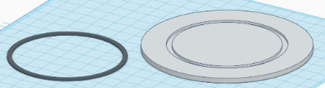
First you need to choose the size. We agreed with the students on the disc diameter of 10 cm. There is a 3.5 mm wide recess inside the disc. The rail has a width of 2.5 mm on the attachment plate. We created a basic model of the wheel in Tinkercad, which we shared among all the members of the student group. Everyone then worked alone on different types of discs.
The basic disc must now be regularly cut into individual parts. The number of parts depends on what fraction the disc represents. We will try the procedure on a disc showing tenths.
We create 2 blocks (holes) with a width of 0.5 mm, which we align next to each other in such a way that they can divide the entire base disc, and merge. Why two blocks, and not just one, we will mention later. Align the object with the disk to the centre. By duplicating and rotating the duplicated object by 36o, we create the necessary number of cuts. We merge everything.
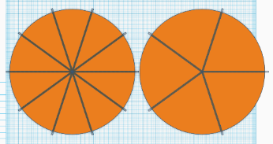
The procedure of two cutting blocks has the advantage that if we now cancel the merging of the duplicated blocks, then when we delete suitable objects, we will simply get a disc divided into fifths. Hence the idea of ​​cutting with two blocks. It makes it easier to cut other denominators (thirds from sixths, fifths from tenths). A half and a quarter can easily be made from an eighth.
It is advisable to place the cut discs in a box. A cylinder with an inner diameter 2 mm wider than the diameter of the discs is offered as a suitable shape. The width of the box wall is 1.25 mm. The lid of the box must have an inner diameter 0.5 mm wider than the outer diameter of the box. In order for the lid to hold nicely on the box, add 4 beaks with a width of 0.25 mm to the upper edge of the box. In the inner part of the lid of the box, we placed a "track" for folding fractions.
Since the total set of wheels has a sufficient number for working in pairs, we created a separate full wheel with a track for the second student as well.
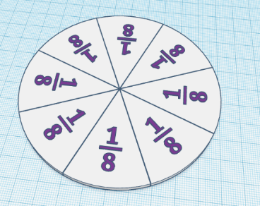
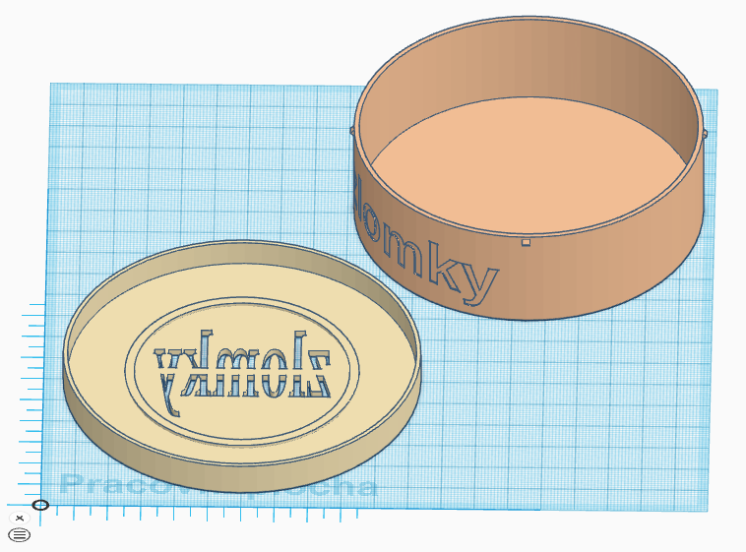

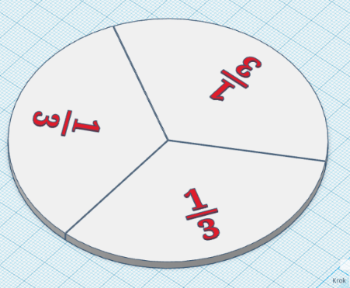
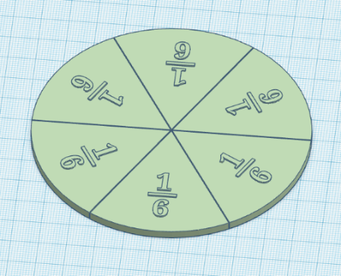

Custom printing is possible and effective in two colors. With correctly chosen colors, the tool is clearer and more interesting for children. We chose the option of white discs with different colored numbers.

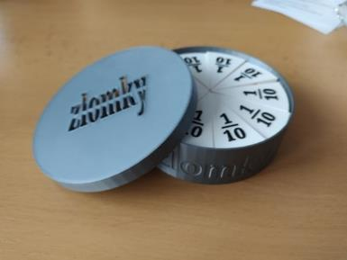
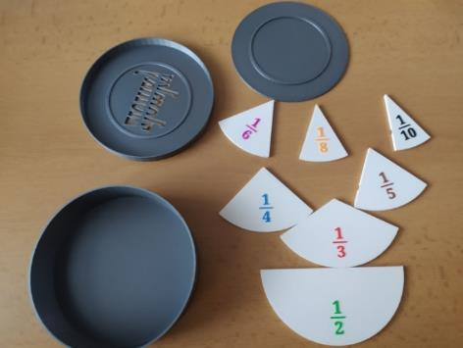
Photo:

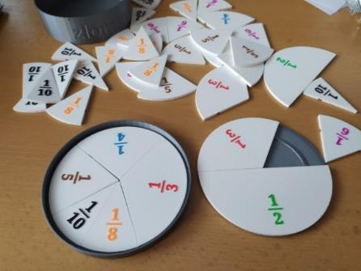
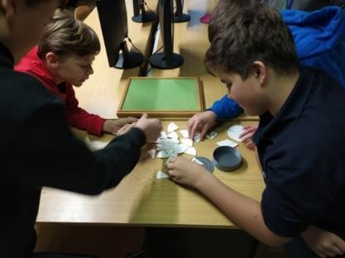

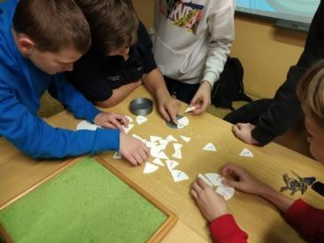
A group of 8th grade students, newly included in the group, worked on the project models, while 6 children actively contributed.
Considering that these students do not yet have enough experience with 3D modelling, the teacher prepared a basic model of the guide rail and an adequate cut-out for it. Students then independently processed individual discs with relief fractional expressions. The work on the box took place in the form of an activity, when the teacher shared an already finished box and the pupils analysed its creation. Their task was to guess why the dimensions of the box were determined in this particular way. This procedure was chosen due to little modelling experience. If more experienced students were to work on the model, we would leave the work on the box to them, we assume only partial interventions and corrections.
Filament consumption for all 7 reels is approximately 150 grams. Consumption when printing the box, lid and backing disc is 80 grams. We estimate the total cost of the filament at 150 CZK.

3D maps
The purpose of this tool does not need to be explained. 3D maps look very attractive as the name suggests, but on the other hand, they are also very complex and almost impossible for the uninitiated. However, there is no need to worry and after a proper explanation of the procedure, students will be able to create almost any 3D map at their own discretion. It is absolutely necessary for the teacher to master this skill and to be able to properly and precisely explain the progress of the work to the pupils. It is a specific procedure that is not intuitive for the students and the teacher must explain the procedure to them. If they understand it, they can then work independently on other 3D maps, for example different mountain ranges, canyons, national parks and the like.
We will show how to create a 3D map on the map of the Czech Republic. Working on 3D maps is not complicated, but it is necessary to take care of some matters.
First it will be the correct setting of the 3D map for export. Here we have to go around all the students to see if they are setting the right parameters.
Return from "preview" back to the map so that students do not lose the work they have started. The touchterrain platform here is not very "conforming" and children will make mistakes here. From the preview, we return to the previous page in the browser with the back button, then we return to the map with the blue link at the very bottom. If we were to return to the previous page with the back button, it may happen that the touchterrain returns us to the original position in the USA. It doesn't happen often, but it can happen, so be careful.
Tinkercad imports may not work 100 % in some browsers. For example, in Mozilla, it is not always possible to drag a file directly into the import window, and the file must be searched "manually" in the directory.
Correct creation of an object with a marked border of the Czech Republic for cutting a 3D map. Here, it is appropriate to let the students design their own procedure to achieve this. The teacher only corrects ideas, or guides students to the correct solution.
Correct alignment of the borders of the Czech Republic and the 3D map of the Czech Republic. It is not necessary to be 100% accurate, that would require a different, more complicated procedure.
Check the finalisation of the model and "calm" the students for too crazy solutions. The 3D map model itself is demanding in terms of print length and the amount of filament used. It is not necessary to make the model more difficult due to a large pad or very prominent text.
Custom map printing can be done in other and better ways. However, we have to take into account that the students are not experienced when working with Slicer. Despite the simple settings they are able to handle, the resulting models are very nice and effective.

Desired characteristics
- the size of the map will be as large as possible given the capabilities of the printer
- it must be clear from the 3D map that it is the Czech Republic, it must have marked borders.
- the fragmentation of the terrain must be clearly visible. It is not necessary to follow the exact scale for this (we will explain later).
- suitable colour of the model corresponding to some colour in the landscape, for example green, brown, grey, not white, black, orange, red.

Method
The work can be divided into four parts. First of all, we have to create a 3D model of the landscape in Tinkercad, then the border of the Czech Republic, in the third part the connection of both models (border + landscape) and finishing the overall appearance of the model. In the last part, we will talk about the print settings.
Model of the landscape of the Czech Republic
Why is creating a landscape model not so complicated? Because the most complex work has already been created for us by companies that deal with the creation of internet maps (e.g. Google) and can be "extracted" from these maps. This page can be used for example:
touchterrain.geol.iastate.edu or jthatch.com (be careful here though, these 3D maps are very detailed and you won't be able to import them into Tinkercad)
Since we are working in Tinkercad and we cannot import maps from jthacht.com into Tinkercad (it is possible, but it is unnecessarily complicated), we will continue to focus on the "touchterrain" platform.
As soon as we open the browser to their site, we will see this image. So let's describe what we are actually interested in on the website:
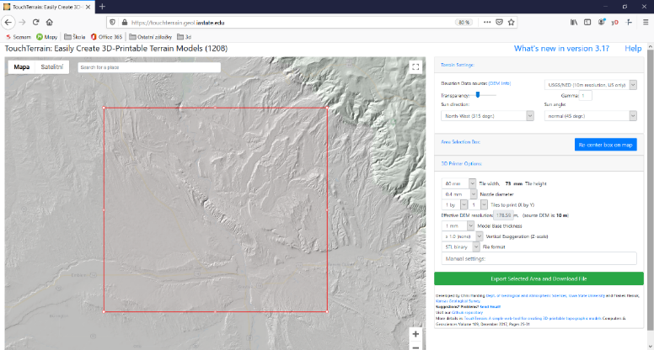
First, the specific map we want. We see this in the left part as a 3D map of the landscape. To see the orientation map, find the item "Transparency" on the right side of the screen and move the mouse bar more to the right.
Then we zoom out the map. For example zooming in and zooming out use + and – at the bottom of the map window, or with the mouse wheel while pressing the ctrl key. After zooming out the map, we already have an overview of where we are (somewhere in the USA in the state of Wyoming), so we can find the Czech Republic.
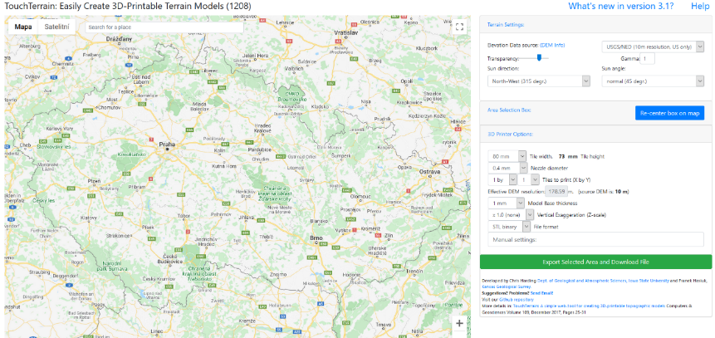

Now comes the important thing. If you wanted to look at the 3D map of the Czech Republic now, it would not be possible. As these are maps created in the USA, the detailed map with 10 metre accuracy is only accessible for the USA. In Europe, we will use an accuracy of 30 metres. You select this in the window right next to the "Transparency" lever. In the window is this text: UGS/NED (10 m resolution, US only). Click the arrow and change to "AW3D30 (30 m resolution, worldwide, good quality). Now you can see how the Czech Republic is covered with a 3D model.
Now we will select the part of the map that we want in our model, so the complete Czech Republic. Place the map of the Czech Republic roughly in the middle of the window and click on "Re-center box on map". The red rectangle indicates which part we want to export. The red rectangle can be moved, enlarged, reduced as we wish. Adjust it so that it covers the entire Czech Republic with a small margin.
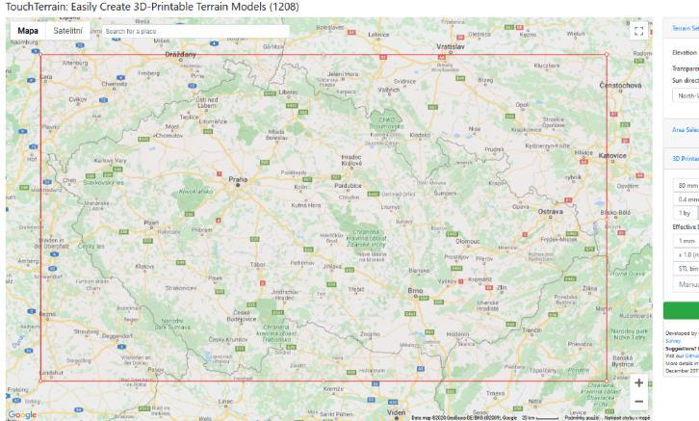

It can be said that now we could export the map to stl format and insert it into tinkercad. Let's see what the resulting model would look like. Click "Export Selected Area and Download file". However, after processing, let's not download the model yet, but let's see how it looks. Click the "Preview STL'' button. This is where the disappointment of the model comes in, as there are virtually no mountains and hills to be seen on it. Of course not, because the elevation is very insignificant considering the size of the landscape. For example, the Czech Republic is roughly 500 kilometres long. The height difference between the highest point (Sněžka) and the lowest point is 1.5 kilometres. Let's imagine a 3D map model of the Czech Republic in dimensions close to our printer. If the length of the Czech Republic model was 25 cm, the height difference would be 0.75 cm, which corresponds to what we see on the model. It is similar to looking at the Czech Republic from a great height or space. We would not be able to distinguish our "mountains" with our eyes. That's why we'll help each other a little.
Let's click the back button and then go back to the map (blue marked text at the very bottom) and adjust the model height a bit.
On the left side, find the item "Vertical Exaggeration (Z-scale)", it says x 1.0 (none). Now the map export is set to match reality exactly. However, we need to highlight the height, so we'll help here. Z-scale can be set differently – from x0.5 (i.e. reduction) to x20 (20fold magnification). You can try different variants, for the Czech Republic I recommend three times the magnification, so x3. Try export and preview.
Download the model you are satisfied with. You can download the model directly from the preview or immediately after export. Just click on the "Download zip file" button. The downloaded zip file contains our model.
In Tinkercad, we click on "Import" and insert our 3D map model.
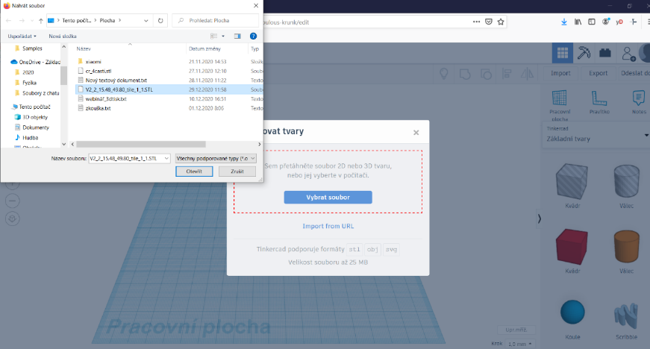

The import will take a while, but please be patient. We enlarge the imported model to the size of the Tinkercad workspace (the Tinkercad workspace roughly corresponds to the printing surface of ordinary 3D printers). We make sure that the model remains on the surface with a small margin.
We must not forget that the magnification must be the same in all proportions, so we zoom in with the "shift" key held down!
Now we have the first part done. For the next phase of work, it is advisable to hide the model in our project (icon with a light bulb).

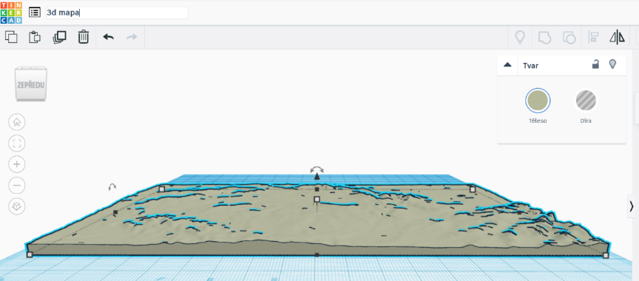

Borders of the Czech Republic
We will search for an image of the Czech Republic map on the internet, if possible in svg format (the format is for vector graphics). You can also use another bitmap image (I recommend a higher resolution) and convert this image to svg format or directly to stl format (3D object).
The conversion can be done online at:
anyconv.com
It is also possible to convert a bitmap or vector image in a graphics program. This is where the Inkspace program seems appropriate.
Inkspace.org
We will insert the map of the Czech Republic into our project in Tinkercad. We will import SVG or stl formats.
The imported object will most likely be too big or too small, so adjust its size. Don't forget to resize in all proportions, i.e. holding down the "shift" key. For now, adjust the size about the same as the 3D map model.
Using a combination of objects, we will now create a "hole" from the map of the Czech Republic, with which we will then cut the Czech Republic into the 3D map. A cuboid, which will be larger than the object of the map of the Czech Republic, is ideal for this. It doesn't matter at all if it interferes outside the desktop, in fact it is almost certainly expected. However, be careful, the map of the Czech Republic must be higher in height (Z axis) in order for the cut-out into the block to be visible at all. Change the CR map object to a "hole", align and merge both objects. We will have a huge block with a cut-out in the shape of the Czech Republic.
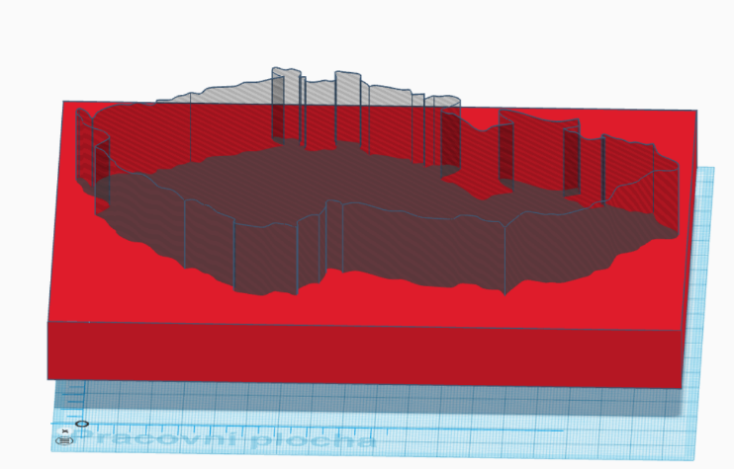

We will change the resulting object to a hole, because we will be cutting the imported 3D map. We will make it visible (click on the light bulb in the right bar).
Now we will adapt the size of the border of the Czech Republic to the model of the Czech Republic. Here it is necessary to be precise and to choose suitable reference points on a regular map and model. We merge both objects (border and 3D map). That's the hard part done.

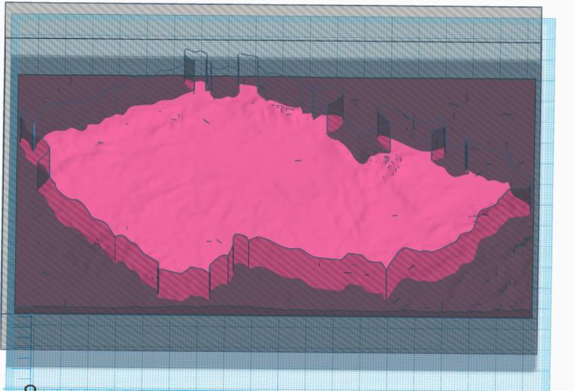
Final modification of the model's appearance
We are missing the last part, which is the overall modification of the model. I'll leave that to your imagination. However, the resulting model should be on a plate indicating which model it is. It can be, for example, a plate with the inscription "Surface of the Czech Republic".
Preparing the model for printing
The final model in Slicer might look something like this:
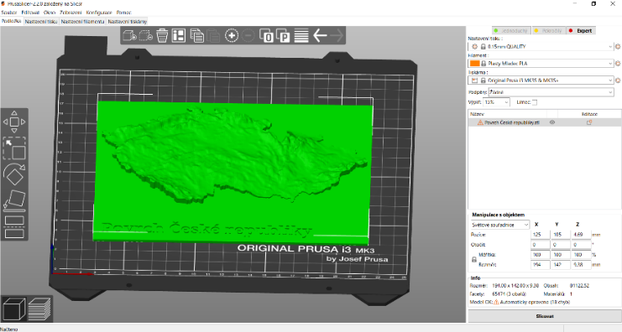
Setting up for a nice print is not difficult. Since we are printing the model "lying down", we can use the preset values ​​"0.15 mm QUALITY". This particular model will be trouble free to print and will probably take more than 7 hours.
.
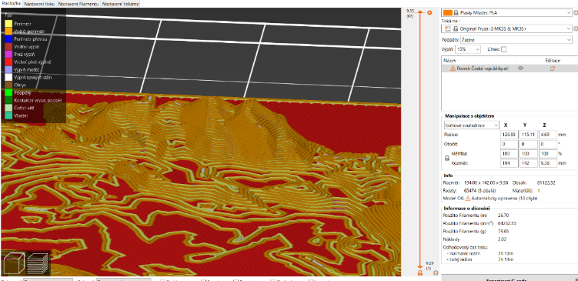

The so-called "variable layer height" can also be used. You can keep “Adaptive” or tweak the settings to your liking. With the correct setting as the model will be smoother in details, time can be saved in parts where a small layer height (base plate) is not necessary.
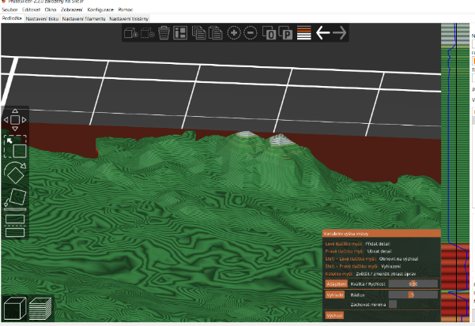

Other possibilities of use
We showed you how to prepare a nice spatial model of the Czech Republic. In this way, a model of any other state, mountain range, canyon or river basin can be prepared. It only depends on the imagination. It is of course possible (and often even better) not to cut the model by borders and leave it as Touchterrain exports it to us.
When slicing the resulting model, there is also the option of printing "upright". This is not suitable for our model, which was cut according to the borders. However, if we want to print a model that does not have significant overhangs, it is advisable to use this printing method. The resulting model looks better even without using variable layer height. However, it is necessary to make sure that we have a sufficiently large contact surface of the model with the pad for the stability of the model during printing.
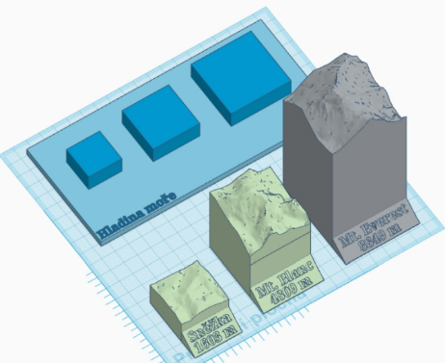
In this way, the students created a more complex model that shows the comparison of Mount Everest, Mont Blanc and Snow White. The landscape relief procedure was almost identical to the previous text (we did not multiply the height), each of the mountains is a separate model that was printed in a different colour. The base was also created separately and contains protrusions for inserting the mountain model. Each mountain has a cavity at the bottom, which corresponds in size to the protrusion on the mat.

Photo:
Due to the circumstances, we had to discuss the work on 3D maps online with the students.
.
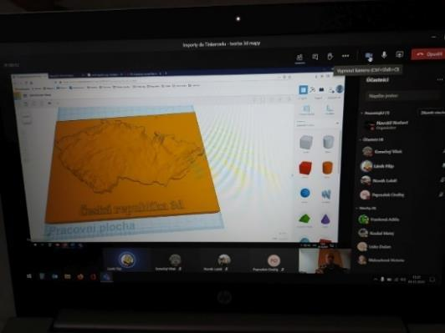

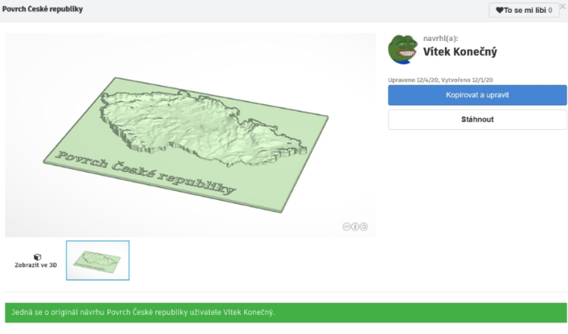

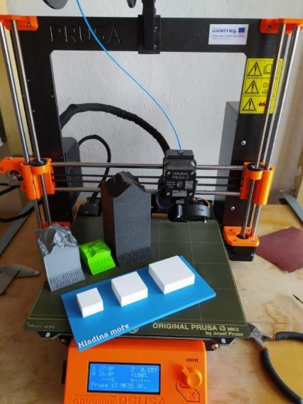
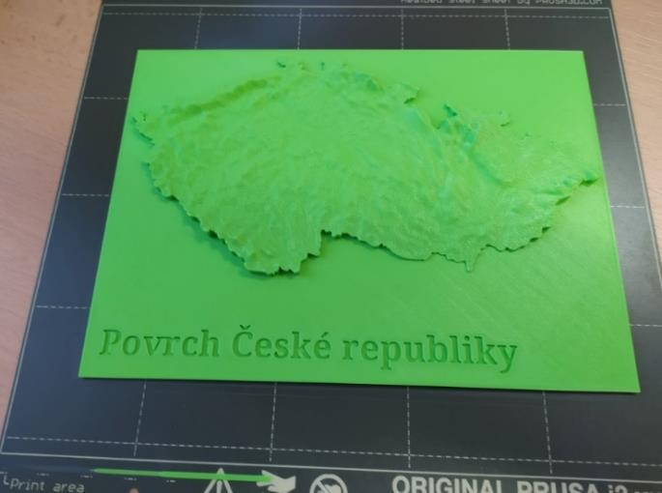
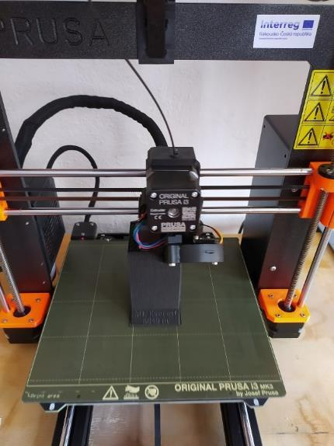
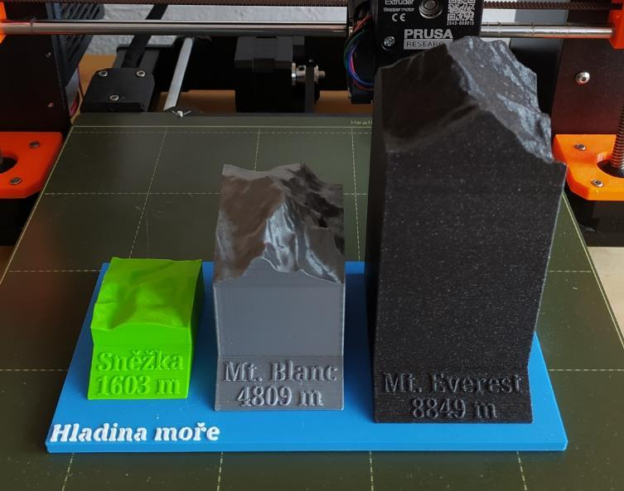

Teaching 3D map creation requires teacher training. It is necessary to create your own trial model in advance, and also to test the functionality of all the links for creating relief and for conversion. Furthermore, it is certainly advisable to have svg images ready for cutting the borders and also to test the imports of stl and svg objects into Tinkercad. Nevertheless, the preparation is not time-consuming and, with sufficient experience, will not exceed one hour.
Explaining the work to the pupils took approximately two hours online. We did not set a specific assignment, we let the students work independently on the models at their discretion. The output was several 3D landscape models in various qualities, 3 members of the group created very successful 3D maps of the Czech Republic, various European states and mountain ranges.
One pupil, after consulting with the teacher, created a very successful model that compares the highest mountain in the Czech Republic with the highest mountain in Europe and the world. He consulted the work on the model with the teacher and the result is a colourful 3D model. The teacher's interventions were only of a technical nature and related to the dimensions and preparation of the model for colour printing.
The consumption of filament is different for different types and sizes of 3D maps, but it is not dizzying. However, due to the choice of a low printing layer, it is necessary to expect a very long printing time.

Commemorative tags for first graders
The first day at school is an important day for every first-grader, which is perceived by the school and children from older years. 9th graders regularly participate in the welcoming of first-graders and give them souvenirs. The students of the 3D modelling and 3D printing class made one such object. Although this is not a teaching aid, it is a commemorative tag with a school motif that every incoming first-grader receives.

Desired characteristics
After an agreement with the school management and members of the class, we agreed that each tag will have a unique colour, shape and drawing. This means that each first grader will receive a unique tag that no one else will have. The drawings were designed by the 1st grade teacher of our elementary school, the students in the circle designed the shapes of the tags and, in cooperation with the art teachers, also the colour combinations.

Method
The work process is very simple, but requires knowledge of converting and importing svg objects into Tinkercad.
The shape of the tags depends only on the students' imagination. Given the assumption that the labels will be printed in groups, it is necessary to agree on the exact height of the substrate, which is the place where the colour of the filament changes. In our case, we agreed on a height of 2 mm for the base of the tag. We set the height of the motif drawing to 0.5 mm. We left the shape and other dimensions free. The only other exact dimension was the hole for the ring with a diameter of 4 mm.
Basic Tinkercad objects can be used to design the tag. Here, we will only draw attention to the issue of rounding the corners of the block object, because it can be a problematic print with an uncertain quality of the overall appearance. Rounding the cuboid is suitable for shaping the tag in the X and Y axes, but in the Z axis it is better to remove the lower and upper rounded parts.

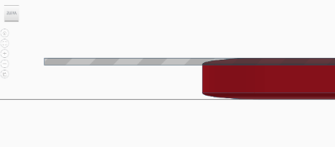
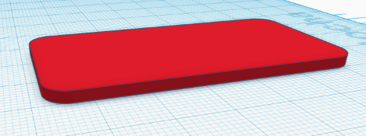

Rounded block Removing the upper part (and subsequently the lower part)

For all tags, due to mass printing, it is necessary to adhere to the specified height, then we place a hole for a key ring in the finished documents.
We place images on the base plates created in this way (logos, inscriptions, etc. can be used). We chose ready-made images.
If we have images in a format other than svg, we need to convert them. This can be done in a vector graphics program (eg Inkscape) or an online converter (eg anyconv.com).

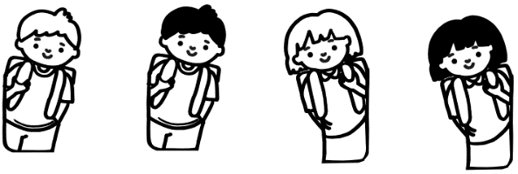

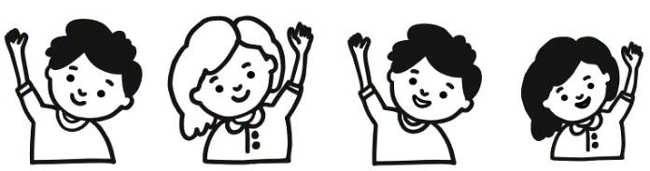

The imported characters are placed appropriately on the base plates and we set the agreed height. A tag created in this way can be printed in two colours even on a printer with one print head. The base plate is printed in one colour, the filament exchange is set at a height of 2.2 mm in the slicer, and the relief with the image is printed in a different colour. By combining different shapes of plates with different images and in different colours, a large number of unique combinations can be achieved.
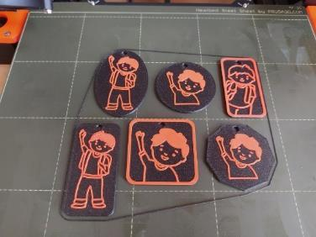
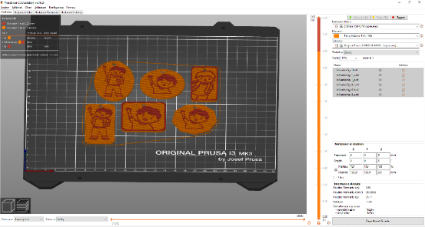
Sample slicing of 6 different labels for printing in the same colours and the resulting print.
The preparation of the teacher only required obtaining suitable topics for tags and their possible modification. A total of 4 students worked on the tags, each of them created several types of tags. The printing itself could already take place during normal lessons, so the students could try slicing under the teacher's supervision, as well as preparing the printer, introducing and replacing the filament, and starting the print themselves.
Filament consumption depends on the size and shape of the tag, and of course also on their number. The tag we created has an average of 12.5 grams, we printed a total of 80 tags. We thus used approximately 1 kg of filament.

Photo:
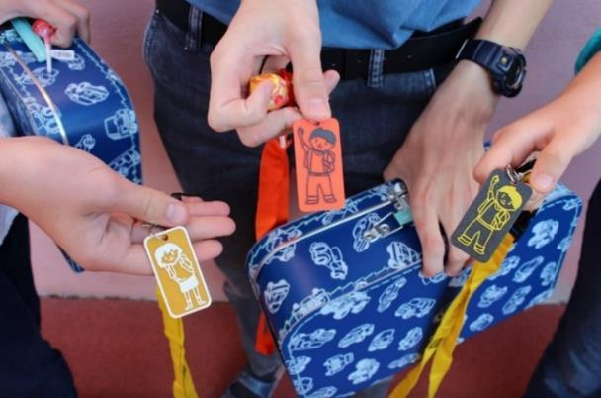
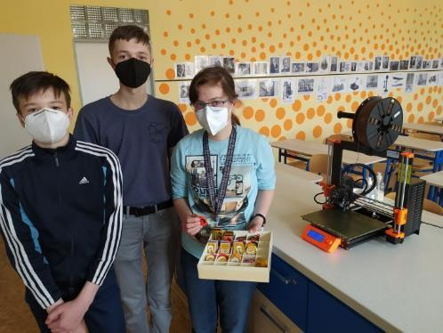

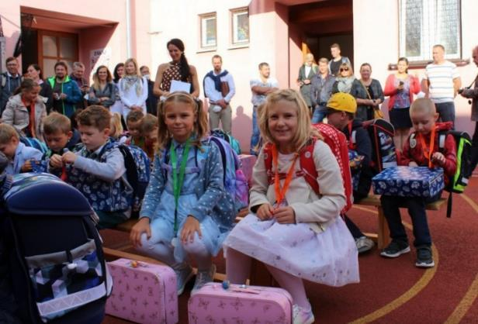

Conclusion
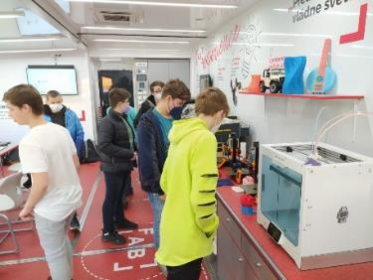
We entered the project with the aim of arousing the interest of sixth through ninth graders in elementary school in new technologies, specifically 3D printing and the related skill of working in 3D space, which is not as easy as it might seem in the two-dimensional environment of the monitor. We also had the ambition to develop children's creativity and technical skills with an overlap into other subjects. We managed to do that. Pupils in the student group worked as a team on aids for mathematics, geography and physics, and also on aids for children in the lower grades of elementary school and for children with special needs. In addition, the interest of the members of the student group in new technologies was also evident during the visit to the FabLab Experience.
We also managed to fulfil another goal, which is the sustainability of the project. The class of 3D modelling and 3D printing will definitely continue in the future. There is a lot of interest even among students from lower grades, and we are already registering requests from teachers from other subjects to create aids for their subjects (chemistry, natural history, English language), we would also like to finalise the aid magnetic letters. However, there is definitely something to create in all subjects. All you need is creativity, an open mind and a desire to learn new things. If children are given space and opportunities, they can achieve great things. This is what we strive for and will continue to strive for in the 3D modelling and 3D printing class.
The 3D printing and 3D modelling class was and still is very popular among other teachers and schools. Our school presented aids made using 3D printing at an exhibition of aids for schools in Znojmo, and they attracted a lot of attention from educators. For many of them, it was very surprising that this technology can be applied even in elementary school.

Ing. Norbert Navratil
M.Sc. Radek Tomaštík
Elementary school nám. Republiky 9, Znojmo

